Dessert Menu
CRÈME BRULEE £8.00
White Chocolate Chip & Madagascan Vanilla Bean, Shortbread, Chefs Sorbet

CHOCOLATE BROWNIE(G/F) £8.00
Warm Dark & White Chocolate Brownie, Orange Puree, Salted Caramel Ice Cream

STICKY TOFFEE PUDDING £8.00
Sticky Date Sponge, Toffee Sauce, Vanilla Ice Cream

APPLE & ALMOND TART £8.00
Warm Apple Frangipane Tart, Candied Pineapple, Honeycomb,
White Chocolate Ice Cream

PANNACOTTA £8.00
Madagascan Vanilla & Amaretto, Berry Compote, Raspberry Sorbet, Tuille

ICE CREAMS & SORBETS £7.00

AFFOGATO £6.00
Vanilla Ice Cream, Espresso

Add Amaretto/ Baileys/Tia Maria £3.00

TEA/COFFEE & TABLET £3.95
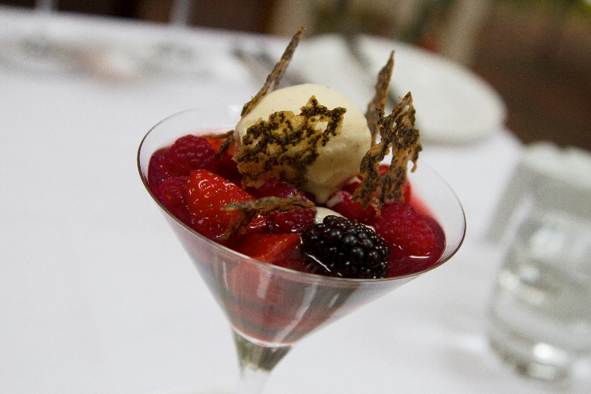
AS A SMALL BUSINESS WE GET CHARGED FOR EVERY CARD TRANSACTION
BY PAYING CASH WE RETAIN 100% OF ITS VALUE AND IT HELPS US TO KEEP OUR PRICES COMPETITIVE
PLEASE SUPPORT US BY PAYING CASH WHEREVER POSSIBLE
(Please let us know Any dietary requirements or allergies)

